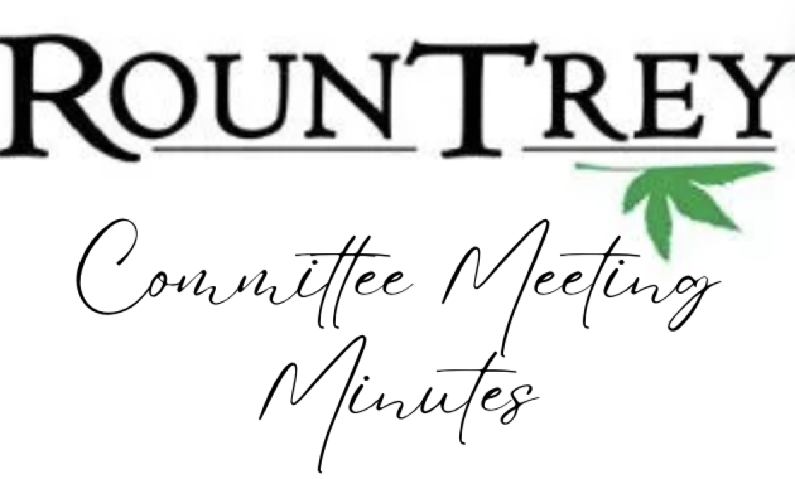

Committee Name: Grounds Committee
Date: 3/26/24
Time: 8:00pm
Location: Clubhouse and via Zoom
Meeting Attendees: Beth Muth, Chris Antonline, Chris Debny, Nancy, Kevin Miller, Donna Poland, Jonathan Taylor, Steve Muth, Mark Campbell, CJ
Meeting Agenda:

STEVE/MARK: updates
- New treasurer CJ Wever joined the team!

Beth:
- EARTH DAY: 4/27, 1-3pm at the Rountrey Clubhouse
  - Naturalist, Brain Sutton to speak about native plants
  - kids activities, birdhouse painting, bird feeder making, earth day chalk art, nature scavenger hunt
  - trying to get Nate Mathis, project manager for the Woolridge road widening project, to attend
- Bamboo: not allowed to plant in neighborhood
- Spring rain has caused a lot of flooding problems, behind houses on Bellstone, on the trails in the dog park, etc.
- Playground mulch; last done in 2022, according to the landscaping team New Markets mulch absolutely needs to be done. Barham and Evershot need to be racked.
- Road construction: “Our current schedule is to relocate utilities this Summer and Fall, which will involve some minor tree clearing in utility easements and then start road construction March 2025, wrapping up by the end of 2026.” from Nate Mathis 2/8/24

- TREES / Kevin Miller
  - NMV: no new updates on trees in easement
  - Arborscapes taking down several trees, including three large ones behind Bellstone
  - crepe myrtles treated $2000
  - silt fence

- TRAILS / Nancy Dunn (RT), Upesh De Silva (NM/NMV)
  - cul de sac/ loop islands need seeding and weed control
  - canford loop bench needs painted and seeding
  - trails flooded, dog park flooded. We discussed how this is a swamp brainstormed ways to improve the area. Need to talk with the county’s wetland conservationist to see what is allowed in an RPA.
  - bushes on trail head need to be mulched

- PONDS / Steve Williams
  - fountain update/James River cleaning out once a month/ Solitude?
  - The waterfall at the entrance will undergo repair work in late April.
  - The waterfall filter is filling with leaves and trash, as it's meant to do to protect the pump. James River will clean this filter on a monthly basis.

- KAYAKS / Chris Antoline
  - RFP out for staining bridges and kayak racks and for building two new ones.
  - for next lottery add a handicap rack option

- STREET LIGHTING /
  - no update

- DOGSTATIONS /
  - no update

- FENCING /
  - price request out for James River to clear behind the Woolridge fence. Neighbors dumping yard debris causing the fence to rot.

- LANDSCAPING & IRRIGATION / Jonathan Taylor (New Market)
irrigation is a priority
new market: new grass project looks great

- PLAYGROUNDS / Chris Debany
  - Playground mulch, New Market will get mulched this year, James River assessing the need of the other two playgrounds.

- DOG PARKS
  - request sent to James River for possible options to improve flooding. Need to account for RPA/ wetland restrictions.

